Knight Online Performance In Korea

Knight Online Trraffic Monitor

`Daily' Graph (5 Minute Average)
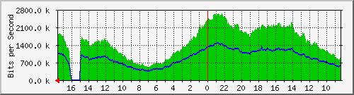
Max In: | 2675.7 kb/s (2.7%) |  | Average In: | 1527.3 kb/s (1.5%) |  | Current In: | 1894.4 kb/s (1.9%)
Max Out: | 1498.0 kb/s (1.5%) |  | Average Out: | 899.7 kb/s (0.9%) |  | Current Out: | 1088.8 kb/s (1.1%)

Knight Onine Game Server at Pentiun3 1.13G Memory 1G
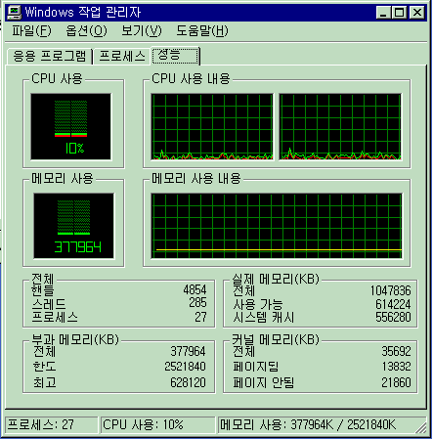

Knight Onine Game Server at Pentiun4 Xeon 2G Memory 1G

